Digital System Design Project 1 – ROBDD Generation

B11030001 葉衍巖

Test1.PLA file :

Boolean function : F = ab’d + a’c’ + bcd’ + cd

Content :

.i 4

.o 1

.ilb a b c d

.ob F

.p 4

10-1 1

0-0- 1

-110 1

--11 1

.e

Out1.dot file:

Content:

digraph ROBDD {

{rank=same 1}

{rank=same 2 3}

{rank=same 4 7}

{rank=same 9}

0 [label=0, shape=box]

1 [label="a"]

2 [label="b"]

3 [label="b"]

4 [label="c"]

7 [label="c"]

9 [label="d"]

16 [label=1, shape=box]

1 -> 2 [label="0", style=dotted]

1 -> 3 [label="1", style=solid]

2 -> 4 [label="0", style=dotted]

2 -> 16 [label="1", style=solid]

3 -> 9 [label="0", style=dotted]

3 -> 7 [label="1", style=solid]

4 -> 16 [label="0", style=dotted]

4 -> 9 [label="1", style=solid]

7 -> 0 [label="0", style=dotted]

7 -> 16 [label="1", style=solid]

9 -> 0 [label="0", style=dotted]

9 -> 16 [label="1", style=solid]

}

Out1.png :

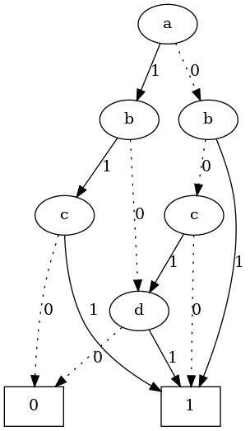

-----------------------------------------------------------------------------------------------------------------

Test2.PLA file:

Boolean function : F = a b’e’ + a’cde’ + a’ce + a’be + ac’d + b’c

Content :

.i 5

.o 1

.ilb a b c d e

.ob F

.p 6

10--0 1

0-110 1

0-1-1 1

01--1 1

1-01- 1

-01-- 1

.e

Out2.dot file :

Content:

digraph ROBDD {

{rank=same 1}

{rank=same 2 3}

{rank=same 4 5 6 7}

{rank=same 11 12 14}

{rank=same 20 24}

0 [label=0, shape=box]

1 [label="a"]

2 [label="b"]

3 [label="b"]

4 [label="c"]

5 [label="c"]

6 [label="c"]

7 [label="c"]

11 [label="d"]

12 [label="d"]

14 [label="d"]

20 [label="e"]

24 [label="e"]

32 [label=1, shape=box]

1 -> 2 [label="0", style=dotted]

1 -> 3 [label="1", style=solid]

2 -> 4 [label="0", style=dotted]

2 -> 5 [label="1", style=solid]

3 -> 6 [label="0", style=dotted]

3 -> 7 [label="1", style=solid]

4 -> 0 [label="0", style=dotted]

4 -> 32 [label="1", style=solid]

5 -> 20 [label="0", style=dotted]

5 -> 11 [label="1", style=solid]

6 -> 12 [label="0", style=dotted]

6 -> 32 [label="1", style=solid]

7 -> 14 [label="0", style=dotted]

7 -> 0 [label="1", style=solid]

11 -> 20 [label="0", style=dotted]

11 -> 32 [label="1", style=solid]

12 -> 24 [label="0", style=dotted]

12 -> 32 [label="1", style=solid]

14 -> 0 [label="0", style=dotted]

14 -> 32 [label="1", style=solid]

20 -> 0 [label="0", style=dotted]

20 -> 32 [label="1", style=solid]

24 -> 32 [label="0", style=dotted]

24 -> 0 [label="1", style=solid]

}

Out2.png :

